INTEGRATIVE COURSE IN PSYCHOLOGY (ICOPSYCH)
ANALYSIS ON THE RESULT OF POST-TEST EXAMINATION IN DEVELOPMENTAL PSYCHOLOGY
MAY 10, 2025

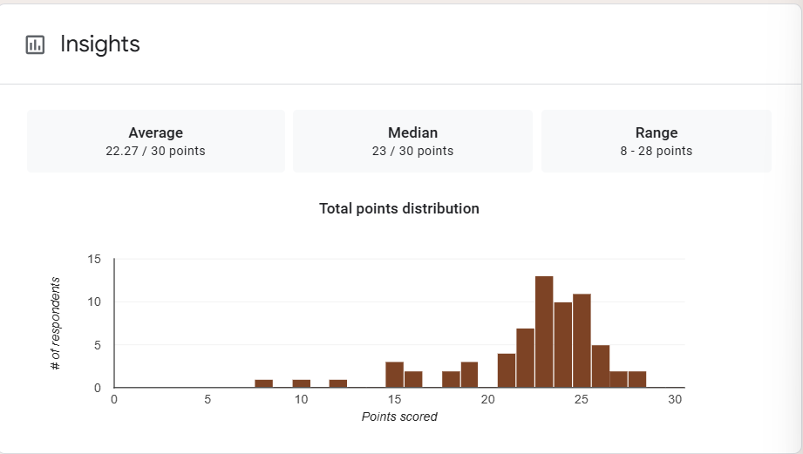

1. Mean Score: The mean score of 22.27 out of 30 is approximately 74.2%, indicating that, on average, students demonstrated a fairly strong understanding of the material. This suggests that the exam content was appropriately challenging and that most students were reasonably well-prepared.

2. Median Score: The median score of 23 (≈76.7%) is slightly higher than the mean. This indicates a slight negative skew, meaning that most students performed above the average, but a few low scores are pulling the mean down slightly.
3. Range: The range is 20 points, from 8/30 (26.7%) to 28/30 (93.3%). This wide spread suggests significant variability in student performance. While some students struggled, others performed exceptionally well, showing a range of understanding levels.
Interpretation Summary:

-The average score (74.2%) and median score (76.7%) indicate that most students performed well.

-The slight negative skew implies a few low-performing students affected the average, but the overall distribution leans toward stronger performance.
-The wide range (8–28) shows diverse student outcomes, suggesting that while many mastered the material, some may require additional support.
-In general, the results reflect a good level of achievement overall, with a need to identify and assist lower-performing students to ensure more consistent understanding across the class.

RATIONALIZATION:

DIFFICULT QUESTIONS:

